**08/10/2021 OOAD SPOT 6 2019103573**

**SPOT EXERCISE**

**i. Refine the class diagram establishing relationships like association, aggregation, composition,**

**class hierarchies (sub class, super class) for the given scenario.**

Quality Building Supply has two kinds of customers: contractors and the general public. Sales to each are slightly different. A contractor buys materials by taking them to the checkout desk for contractors. The clerk enters the contractor's name into the system. The system displays the contractor's information, including current credit standing. The clerk then opens up a new ticket (sale) for the contractor. Next, the clerk scans in each item to be purchased. The system finds the price of the item and adds the item to the ticket. At the end of the purchase, the clerk indicates the end of the sale. The system compares the total amount against the contractor's current credit limit and, if it is acceptable, finalizes the sale. The system creates an electronic ticket for the items, and the contractor's credit limit is reduced by the amount of the sale. Some contractors like to keep a record of their purchases, so they request that ticket details be printed. Others aren't interested in a printout. A sale to the general public is simply entered into the cash register, and a paper ticket is printed as the items are identified. Payment can be by cash, check, or credit card. The clerk must enter the type of payment to ensure that the cash register balances at the end of the shift. For credit card payments, the system prints a credit card voucher that the customer must sign.

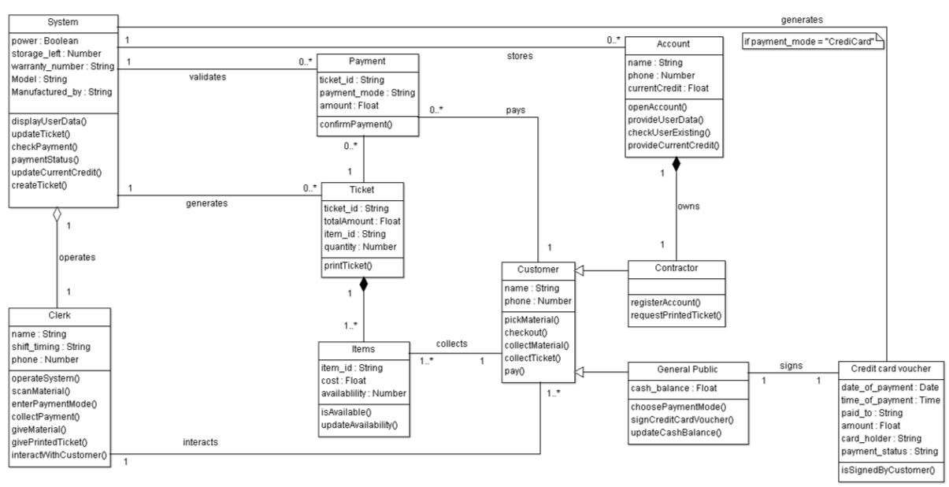**Class diagram with conceptual class hierarchies, association, aggregation & composition relationships:**

**Conceptual class hierarchies:**

|  |  |
| --- | --- |
| **Super Class** | **Sub Class** |
| Customer | Contractor |
| General Public |

**Association relationship:**

|  |  |  |
| --- | --- | --- |
| **Class-1** | **Role** | **Class-2** |
| System | stores | Account |
| System | validates | Payment |
| System | generates | Ticket |
| System | generates | Credit card voucher |
| Clerk | interacts | Customer |
| Customer | pays | Payment |
| Customer | collects | Item |
| General Public | signs | Credit card voucher |

**Aggregation relationship:**

|  |  |
| --- | --- |
| **Class of group elements** | **Class of groups** |
| Clerk | System |

**Composition relationship:**

|  |  |
| --- | --- |
| **Class of components** | **Class of composites** |
| Item | Ticket |
| Contractor | Account |